Project: Displaying Regular Polygons

Problem Description:

Create a subclass of JPanel, named RegularPolygonPanel, to paint an n-sided regular polygon. The class contains a property named numberOfSides, which specifies the number of sides in the polygon. The polygon is centered at the center of the panel. The size of the polygon is proportional to the size of the panel. Create a pentagon, hexagon, heptagon, and octagon, nonagon, and decagon from RegularPolygonPanel and display them in a frame, as shown in the figure below.

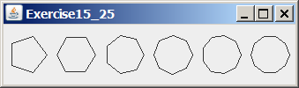

Your Task:
- Create a class named RegularPolygonPanel to paint an n-sided regular polygon. (So, if n is 3, it paints a triangle, if n is 4, it paints a square, etc.)
- Create a frame classes that contains pentagon, hexagon, heptagon, and octagon, nonagon, and decagon. These objects are created from RegularPolygonPanel.
- Draw a UML diagram for RegularPolygonPanel class and the frame class.

Submit the following items: Folder last_first containes your *.java and *.class to Zeus

2. Fill in self-evaluation:

- Can your program create the UI? _______________
- Can your program display polygons correctly?

